# Two different ways to control real robot arm

# 1 [Task Summary]

Here we are going to introduce two different ways to control real robot through codes.

# 2 [Details]

**(1) Directly send the position message to the robot**

Let us take a look at the test_move.py file

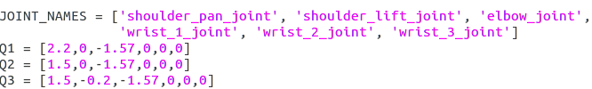

At first we create Q1, Q2, Q3 matrices to store three different pose’s joints angles.



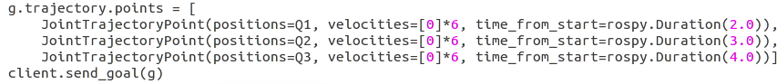

Then we create a FollowJointTrajectoryGoal() object and put the joints angles information into this object. Finally, sending it to the robot.

**(2) Use Moveit to compute the path and send it to robot**

Let us take a look at teleop_cartesian.py file



We create a move group firstly.



Then we set a goal and ask moveit function plan() to calculate a trajectory.

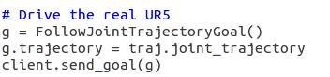

Finally we send the trajectory to real UR5.